**Capital University of Science & Technology**

**Term Project Proposal**

Department of Electrical and Computer Engineering

|  |  |  |  |
| --- | --- | --- | --- |
| **Project Title** | | Card Picking Game | |
| **Course Title** | | Application of Information and Communication Technology Lab | |
| **Sr. No.** | **Student Name** | | **Registration Number** |
| **01.** | Mohsin Rasul | | BCY243024 |
| **02.** | Rana Rameez Mushtaq | | BCY243023 |

|  |
| --- |
| **Idea:** This project involves developing a card-picking game using C++ programming. The game uses random numbers to simulate the shuffling and selection of cards from a standard deck of 52 cards. Players compete to achieve predefined goals, such as obtaining the highest score, collecting cards of a specific suit, or forming specific card combinations. The program ensures that each card is unique and not repeated during a single game.  **Objectives:** 1- Develop a C++ program that uses random number generation to simulate card shuffling and picking. 2- Design game logic to calculate scores based on the selected cards and defined rules. 3- Utilize programming constructs like loops, conditionals, arrays, and functions to implement game mechanics. 4- Create a text-based user interface for gameplay and results display. **Applications:** 1- Demonstrates the use of randomness in programming through a practical application. 2- Serves as a basic model for creating card-based games like Poker, Solitaire, or Rummy. 3- Provides a fun way to teach and reinforce key programming concepts. 4- Can be extended to include advanced features like multiplayer support, game statistics, or visual interfaces. |

**Block Diagram:** 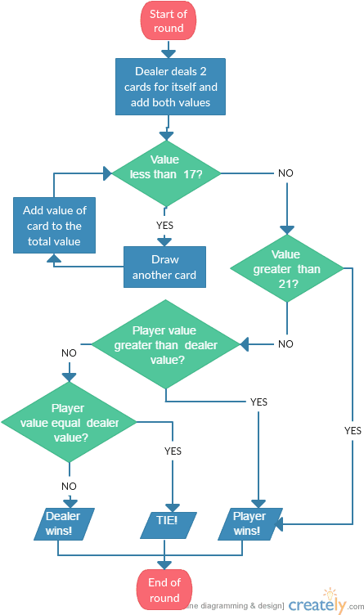

|  |  |
| --- | --- |
| **Instructor Remarks** | **Student 1 Signature: __________________** |
| **Student 2 Signature: __________________** |
| **Instructor’s Signature: ________________** | **Date: ___________________** |